Brownfield Land Register
2025 Part 1



Produced by Forward Planning
Rossendale Borough Council
The Business Centre,
Futures Park, Bacup,
OL13 0BB
www.rossendale.gov.uk

Contents Page
ALBERT MILL, WHITWORTH 4
HARE AND HOUNDS GARAGE, STACKSTEADS 6
14 DEARDENGATE, HASLINGDEN 8
LOVECLOUGH WORKING MENS CLUB 10
LAND OFF LEES ST, BRITANNIA 12
1 LABURNUM STREET, HASLINGDEN 14
BOLTON AND CARR MILLS, COWPE 16
KNOTT MILL WORKS, MILLER BARN LANE, WATERFOOT 18
LAND AT BLACKWOOD ROAD, STACKSTEADS 20
MAGISTRATES COURT, RAWTENSTALL 22
OLD MARKET HALL, BACUP 24
WATERSIDE MILL, BACUP 26
LAND TO SIDE AND REAR OF PETROL STATION, MANCHESTER ROAD 28
BREARLEY ST GARAGE SITE 30
VILLAGE PINE GLEN TOP WORKS, STACKSTEADS 32
THE HERITAGE ARCADE AND ADJACENT BUILDINGS AT 23-27 BACUP ROAD, RAWTENSTALL 34
LAND EAST OF MARKET STREET, EDENFIELD 36
FMR HASLINGDEN POLICE STATION 38
FORMER CAR PARK, PARK ROAD, HELMSHORE 40
2 WARNER ST, HASLINGSDEN 42
CROWN INN, GREAVE RD, BACUP 44
IRWELL VALE MILL 46
GLEN MILL, STACKSTEADS 48
FMR COMMERCIAL HOTEL, STACKSTEADS 50
ADJACENT 93 BURNLEY ROAD BACUP LANCASHIRE OL13 8PZ 52
THE OFFICES PEEL MILL MARKET STREET SHAWFORTH ROCHDALE LANCASHIRE OL12 8HN 54

Organisation URI | http://opendatacommunities.org/id/district-council/rossendale
Site Reference | ROSBS001
Site Name / Address | ALBERT MILL, WHITWORTH
Site plan URL | https://www.rossendale.gov.uk/downloads/download/10897/brownfield_register
GeoY | 53.6531
GeoX | -2.17781
Hectares | 1.53
Ownership Status | not owned by a public authority
Deliverable
Planning Status | Not permissioned
Permission Type
Permission Date
Planning History | https://publicaccess.rossendale.gov.uk/online-  applications/propertyDetails.do?activeTab=relatedCases&keyVal=MJLQHI00DT00L
Net Dwellings Range From | 85
Net Dwellings Range To
Hazardous Substances
Notes | 2019/0341 full planning application was granted for 85 units in November 2020 but has since expired. The Local Plan allocates the site (H59) for 85 dwellings.
First Added Date | 12/15/2017
Last Updated Date | 10/12/2025

Map | 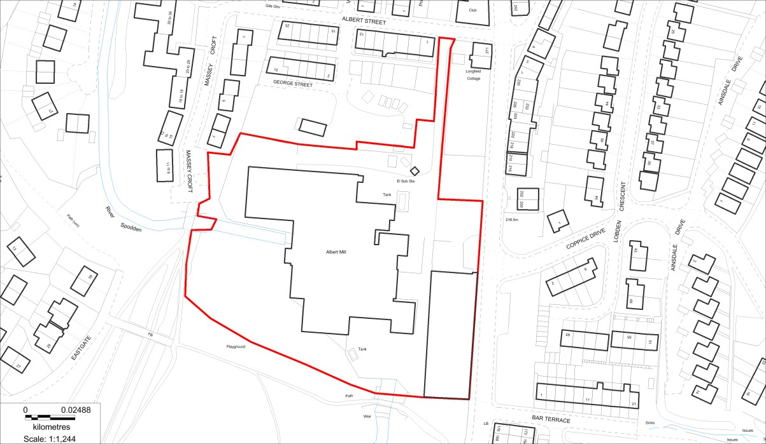  N  ▲  (c) Crown copyright and database rights 2025 OS AC0000820722. You are permitted to use this data solely to enable you to respond to, or interact with, the organisation that provided you with the data. You are not permitted to copy, sub-licence, distribute or sell any of this data to third parties in any form.

Organisation URI | http://opendatacommunities.org/id/district-council/rossendale
Site Reference | ROSBS009
Site Name / Address | HARE AND HOUNDS GARAGE, STACKSTEADS
Site plan URL | https://www.rossendale.gov.uk/downloads/download/10897/brownfield_register
GeoY | 53.6923
GeoX | -2.23197
Hectares | 0.15
Ownership Status | Not owned by a public authority
Deliverable | No
Planning Status | Not permissioned
Permission Type
Permission Date
Planning History | https://publicaccess.rossendale.gov.uk/online-applications/applicationDetails.do?activeTab=summary&keyVal=NIUF3UND02K00
Net Dwellings Range From | 9
Net Dwellings Range To
Hazardous Substances
Notes | 2015/0030 - outline approval has expired. The Local Plan allocates the site (H32) for 9 dwellings.
First Added Date | 15/12/2017
Last Updated Date | 10/12/2025

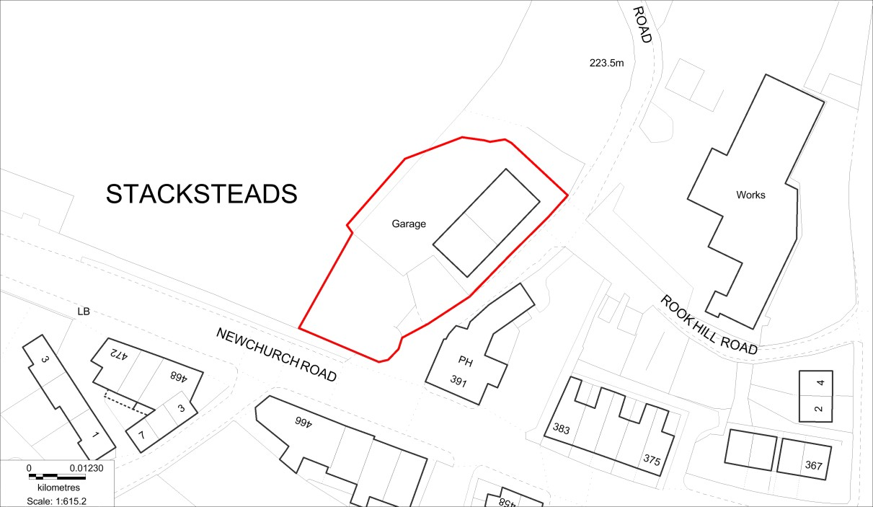
N
▲

(c) Crown copyright and database rights 2025 OS AC0000820722. You are permitted to use this data solely to enable you to respond to, or interact with, the organisation that provided you with the data. You are not permitted to copy, sub-licence, distribute or sell any of this data to third parties in any form.

Organisation URI | http://opendatacommunities.org/id/district-council/rossendale
Site Reference | ROSBS012
Site Name / Address | 14 DEARDENGATE, HASLINGDEN
Site plan URL | https://www.rossendale.gov.uk/downloads/download/10897/brownfield_register
GeoY | 53.7062
GeoX | -2.32463
Hectares | 0.06
Ownership Status | not owned by a public authority
Deliverable | No
Planning Status | Not permissioned
Permission Type
Permission Date
Planning History | https://publicaccess.rossendale.gov.uk/online-applications/applicationDetails.do?activeTab=summary&keyVal=O0H4WBND02K00
Net Dwellings Range From | 6
Net Dwellings Range To
Hazardous Substances
Notes | 2016/0001 planning permission for the conversion of first floor into 6 no. flats expired in March 2019.
First Added Date | 15/12/2017
Last Updated Date | 26/11/2024

Map | 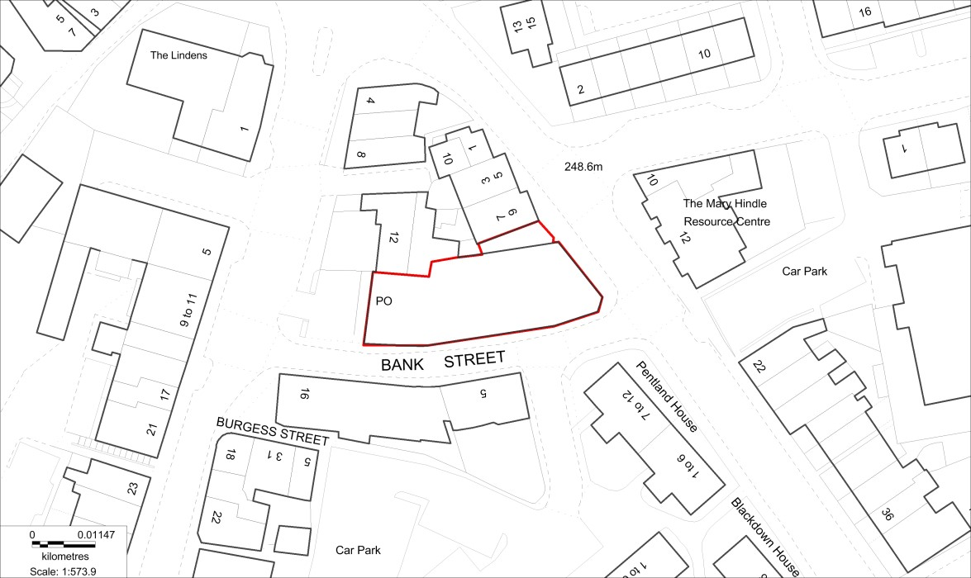  N  ▲  (c) Crown copyright and database rights 2025 OS AC0000820722. You are permitted to use this data solely to enable you to respond to, or interact with, the organisation that provided you with the data. You are not permitted to copy, sub-licence, distribute or sell any of this data to third parties in any form.

Organisation URI | http://opendatacommunities.org/id/district-council/rossendale
Site Reference | ROSBS013
Site Name / Address | LOVECLOUGH WORKING MENS CLUB
Site plan URL | https://www.rossendale.gov.uk/downloads/download/10897/brownfield_register
GeoY | 53.7399
GeoX | -2.28612
Hectares | 0.44
Ownership Status | Not owned by public authority
Deliverable | No
Planning Status | Not permissioned
Permission Type | Full planning permission
Permission Date | 11/03/2013
Planning History | https://publicaccess.rossendale.gov.uk/online-applications/applicationDetails.do?activeTab=summary&keyVal=ZZZZXANDJV936
Net Dwellings Range From | 10
Net Dwellings Range To
Hazardous Substances
Notes | Part of the allocation site H11 in the Local Plan. 2011/0457 permissioned. Planning permission expired.
First Added Date | 15/12/2017
Last Updated Date | 10/12/2025

Map | 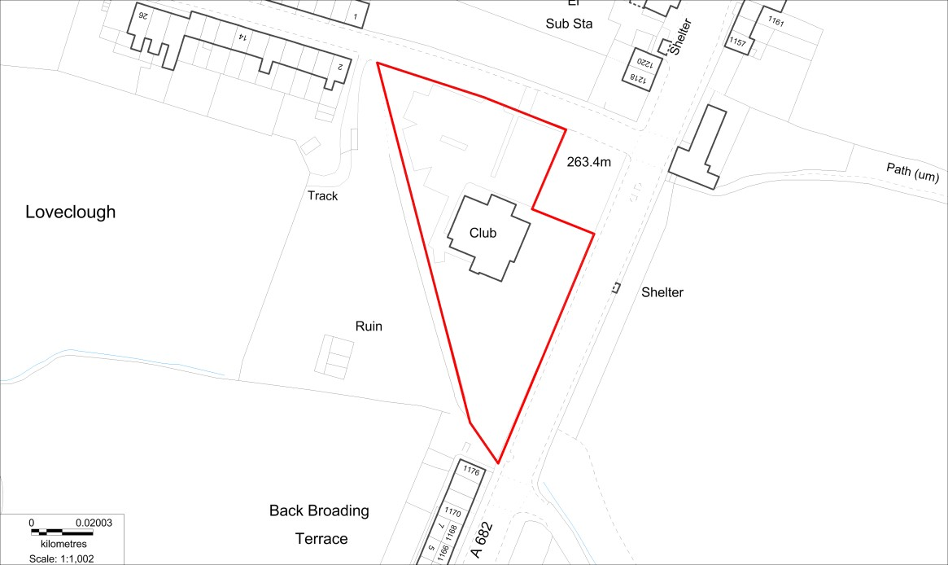  N  ▲  (c) Crown copyright and database rights 2025 OS AC0000820722. You are permitted to use this data solely to enable you to respond to, or interact with, the organisation that provided you with the data. You are not permitted to copy, sub-licence, distribute or sell any of this data to third parties in any form.

Organisation URI | http://opendatacommunities.org/id/district-council/rossendale
Site Reference | ROSBS020
Site Name / Address | LAND OFF LEES ST, BRITANNIA
Site plan URL | https://www.rossendale.gov.uk/downloads/download/10897/brownfield_register
GeoY | 53.6919
GeoX | -2.18283
Hectares | 0.07
Ownership Status | Owned by a public authority
Deliverable | Yes
Planning Status | Not permissioned
Permission Type | Reserved Matters
Permission Date | 30/11/2006
Planning History | https://publicaccess.rossendale.gov.uk/online-applications/applicationDetails.do?activeTab=summary&keyVal=ZZZZWVNDJV796
Net Dwellings Range From | 4
Net Dwellings Range To
Hazardous Substances
Notes | 2006/393 (Reserved Matters); 2006/0189. Planning permission expired.
First Added Date | 15/12/2017
Last Updated Date | 10/12/2025

Map | 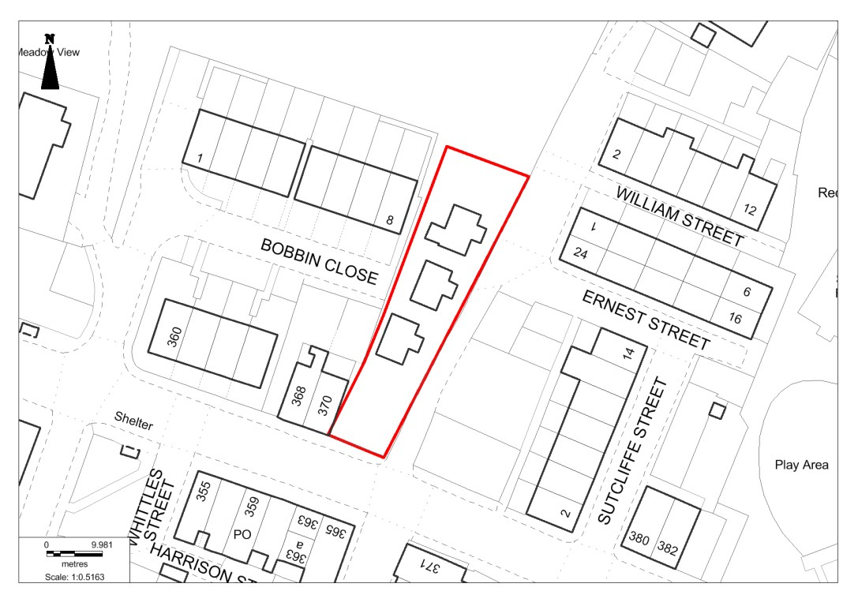  (c) Crown copyright and database rights 2025 OS AC0000820722. You are permitted to use this data solely to enable you to respond to, or interact with, the organisation that provided you with the data. You are not permitted to copy, sub-licence, distribute or sell any of this data to third parties in any form.

Organisation URI | http://opendatacommunities.org/id/district-council/rossendale
Site Reference | ROSBS022
Site Name / Address | 1 LABURNUM STREET, HASLINGDEN
Site plan URL | https://www.rossendale.gov.uk/downloads/download/10897/brownfield_register
GeoY | 53.7062
GeoX | -2.3284
Hectares | 0.04
Ownership Status | Not owned by a public authority
Deliverable | No
Planning Status | Not permissioned
Permission Type
Permission Date
Planning History | https://publicaccess.rossendale.gov.uk/online-applications/applicationDetails.do?activeTab=summary&keyVal=ZZZZXANDJV096
Net Dwellings Range From | 8
Net Dwellings Range To
Hazardous Substances
Notes | The Local Plan allocates the site (H41) for 8 dwellings.  Conversion from retail shop and warehouse to 8 no. dwellings
First Added Date | 15/12/2017
Last Updated Date | 10/12/2025

Map | 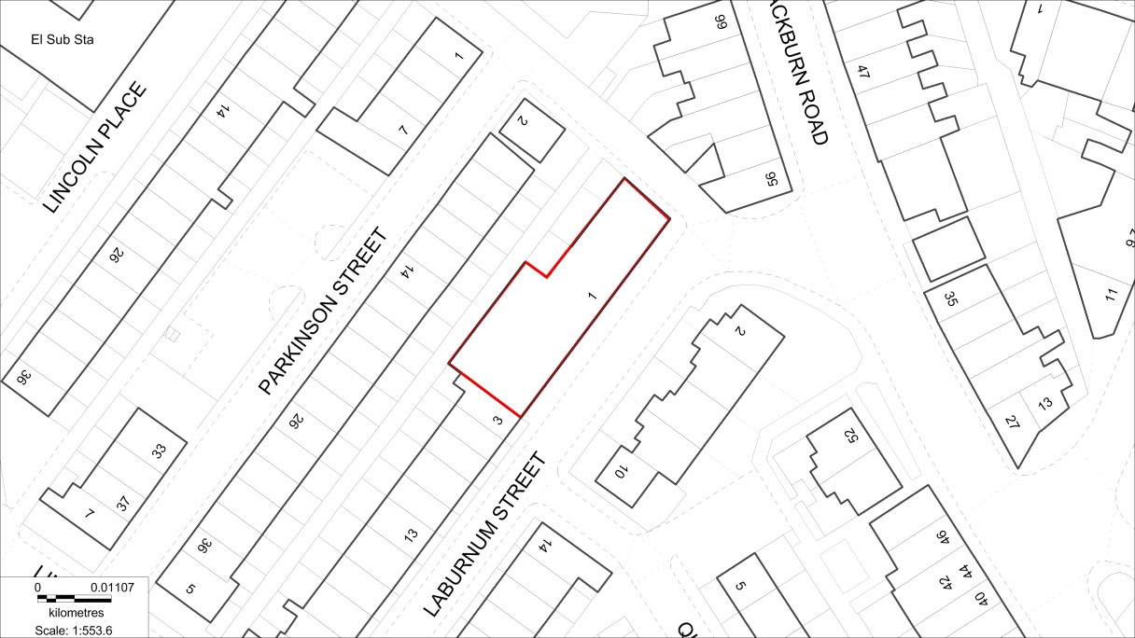  N  ▲  (c) Crown copyright and database rights 2025 OS AC0000820722. You are permitted to use this data solely to enable you to respond to, or interact with, the organisation that provided you with the data. You are not permitted to copy, sub-licence, distribute or sell any of this data to third parties in any form.

Organisation URI | http://opendatacommunities.org/id/district-council/rossendale
Site Reference | ROSBS024
Site Name / Address | BOLTON AND CARR MILLS, COWPE
Site plan URL | https://www.rossendale.gov.uk/downloads/download/10897/brownfield_register
GeoY | 53.690263
GeoX | -2.250402
Hectares | 0.22
Ownership Status | Not owned by a public authority
Deliverable | No
Planning Status | Not permissioned
Permission Type
Permission Date
Planning History
Net Dwellings Range From | 11
Net Dwellings Range To
Hazardous Substances
Notes | The Local Plan allocates the site (H50) for 11 dwellings. Planning application 2017/0130 approved 01 Mar 2018. Planning permission expired.
First Added Date | 15/12/2017
Last Updated Date | 10/12/2025

Map | 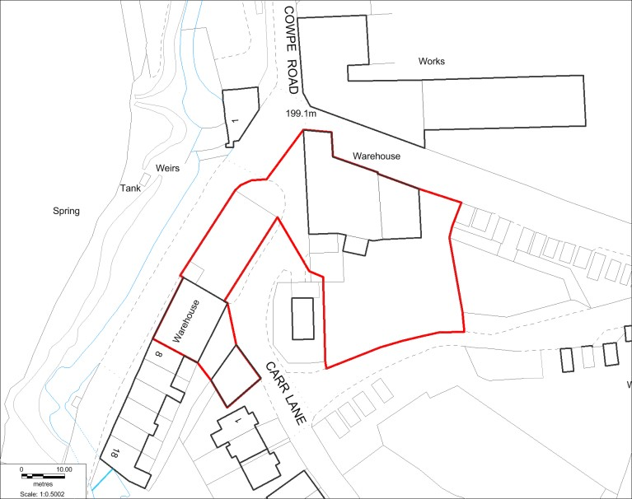  N  ▲  (c) Crown copyright and database rights 2025 OS AC0000820722. You are permitted to use this data solely to enable you to respond to, or interact with, the organisation that provided you with the data. You are not permitted to copy, sub-licence, distribute or sell any of this data to third parties in any form.

Organisation URI | http://opendatacommunities.org/id/district-council/rossendale
Site Reference | ROSBS030
Site Name / Address | KNOTT MILL WORKS, MILLER BARN LANE, WATERFOOT
Site plan URL | https://www.rossendale.gov.uk/downloads/download/10897/brownfield_register
GeoY | 53.6928
GeoX | -2.25074
Hectares | 0.06
Ownership Status | Not owned by a public authority
Deliverable | Yes
Planning Status | Permissioned
Permission Type | Full Planning Permission
Permission Date | 28/08/2024
Planning History | https://publicaccess.rossendale.gov.uk/online-applications/applicationDetails.do?activeTab=documents&keyVal=SEK98TNDLKS00
Net Dwellings Range From | 5
Net Dwellings Range To
Hazardous Substances
Notes | Application 2024/0239 approved for residential. Allocated in the Local Plan (H51) for 5 dwellings.
First Added Date | 15/12/2017
Last Updated Date | 10/12/2025

Map | 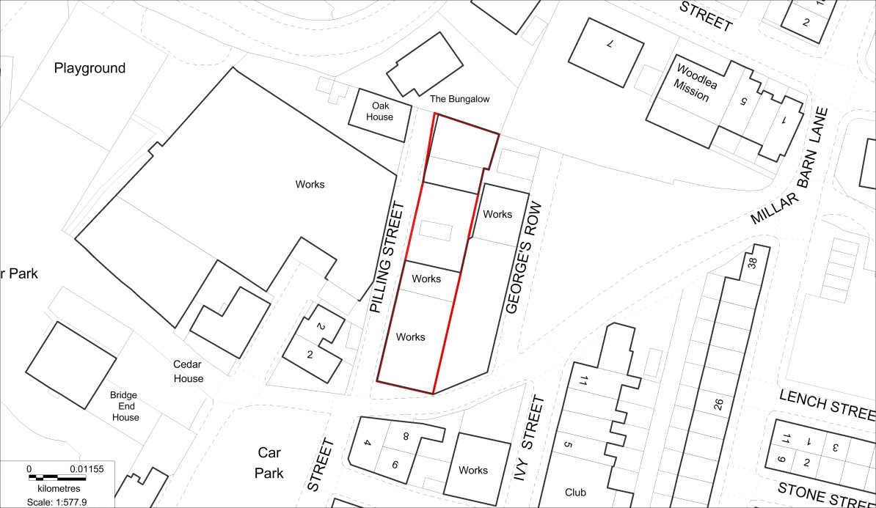  N  ▲  (c) Crown copyright and database rights 2025 OS AC0000820722. You are permitted to use this data solely to enable you to respond to, or interact with, the organisation that provided you with the data. You are not permitted to copy, sub-licence, distribute or sell any of this data to third parties in any form.

Organisation URI | http://opendatacommunities.org/id/district-council/rossendale
Site Reference | ROSBS032
Site Name / Address | LAND AT BLACKWOOD ROAD, STACKSTEADS
Site plan URL | https://www.rossendale.gov.uk/downloads/download/10897/brownfield_register
GeoY | 53.6884
GeoX | -2.23073
Hectares | 1.23
Ownership Status | Not owned by a public authority
Deliverable | Yes
Planning Status | Permissioned
Permission Type | Full Planning permissioned
Permission Date | 11/05/2022
Planning History | https://publicaccess.rossendale.gov.uk/online-applications/applicationDetails.do?keyVal=QYEQ1HNDN0P00&activeTab=summary
Net Dwellings Range From | 41
Net Dwellings Range To
Hazardous Substances
Notes | Application 2021/0500 for 41 dwellings has been approved. The Local Plan allocates the site (H22) for 41 dwellings.
First Added Date | 15/12/2017
Last Updated Date | 10/12/2025

Map | 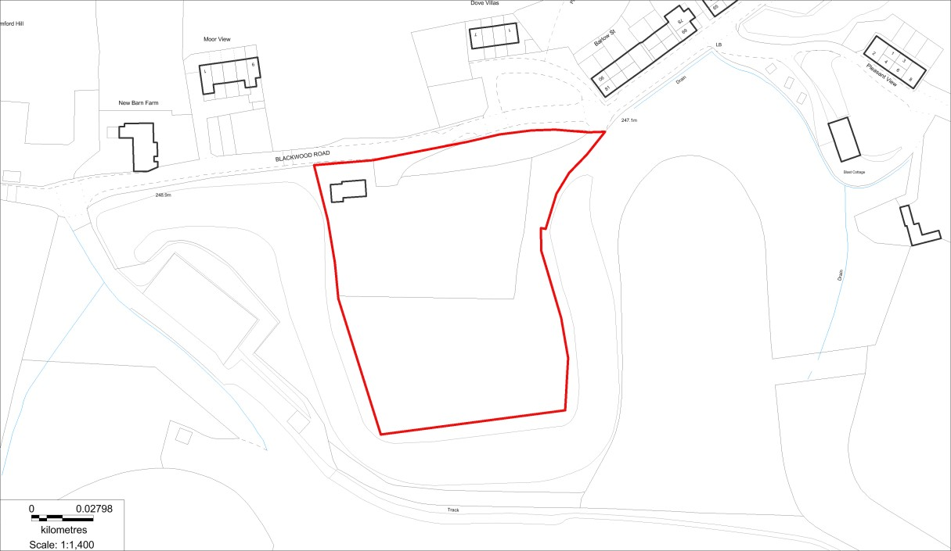  N  ▲  (c) Crown copyright and database rights 2025 OS AC0000820722. You are permitted to use this data solely to enable you to respond to, or interact with, the organisation that provided you with the data. You are not permitted to copy, sub-licence, distribute or sell any of this data to third parties in any form.

Organisation URI | http://opendatacommunities.org/id/district-council/rossendale
Site Reference | ROSBS034
Site Name / Address | MAGISTRATES COURT, RAWTENSTALL
Site plan URL | https://www.rossendale.gov.uk/downloads/download/10897/brownfield_register
GeoY | 53.7003
GeoX | -2.29152
Hectares | 0.03
Ownership Status | Not owned by a public authority
Deliverable | No
Planning Status | Permissioned
Permission Type | Full Planning permissioned
Permission Date | 16/10/2014
Planning History | https://publicaccess.rossendale.gov.uk/online-applications/applicationDetails.do?activeTab=summary&keyVal=N5XRCBNDKLH00
Net Dwellings Range From | 11
Net Dwellings Range To
Hazardous Substances
Notes | Planning application: 2014/0233. The Local Plan allocates the site (H1) for 11 dwellings.
First Added Date | 15/12/2017
Last Updated Date | 10/12/2025

Map | 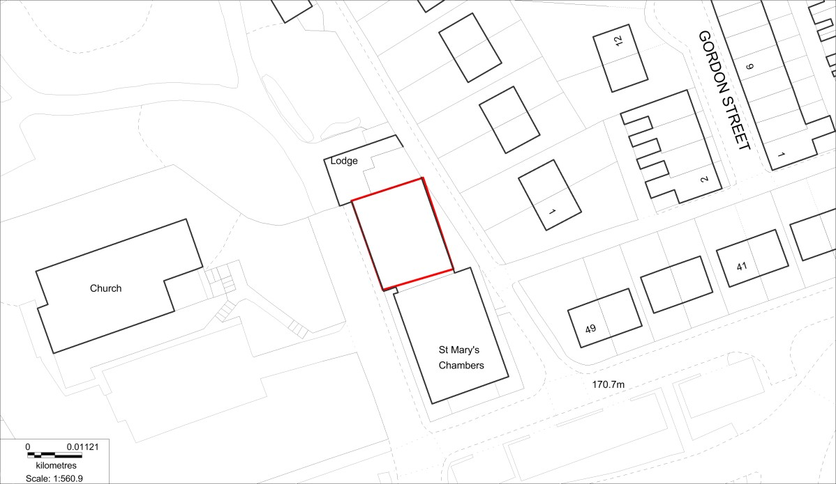  N  ▲  (c) Crown copyright and database rights 2025 OS AC0000820722. You are permitted to use this data solely to enable you to respond to, or interact with, the organisation that provided you with the data. You are not permitted to copy, sub-licence, distribute or sell any of this data to third parties in any form.

Organisation URI | http://opendatacommunities.org/id/district-council/rossendale
Site Reference | ROSBS035
Site Name / Address | OLD MARKET HALL, BACUP
Site plan URL | https://www.rossendale.gov.uk/downloads/download/10897/brownfield_register
GeoY | 53.7021
GeoX | -2.20192
Hectares | 0.16
Ownership Status | Not owned by a public authority
Deliverable | Yes
Planning Status | Permissioned
Permission Type | Full Planning Permission
Permission Date | 19/10/2023
Planning History | https://publicaccess.rossendale.gov.uk/online-applications/propertyDetails.do?activeTab=relatedCases&keyVal=MJLQLE00DT01Z
Net Dwellings Range From | 8
Net Dwellings Range To | 16
Hazardous Substances
Notes | The Local Plan allocates the site (H17) for 16 dwellings.  2022/0444 – an application for 8 dwellings has been approved.
First Added Date | 15/12/2017
Last Updated Date | 10/12/2025

Map | 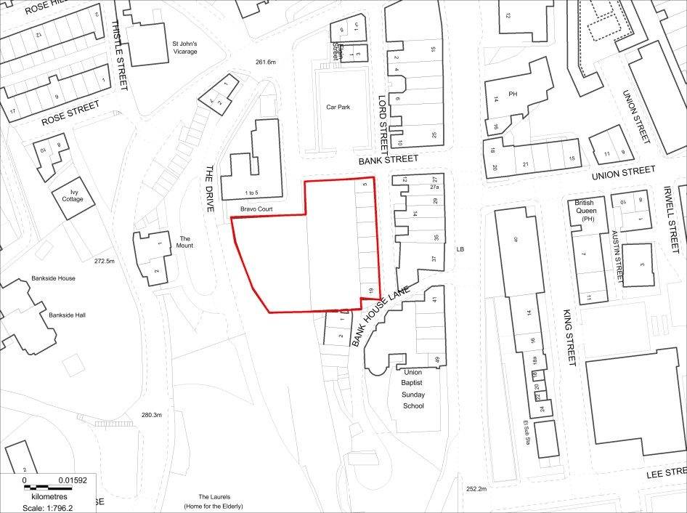  N  ▲  (c) Crown copyright and database rights 2025 OS AC0000820722. You are permitted to use this data solely to enable you to respond to, or interact with, the organisation that provided you with the data. You are not permitted to copy, sub-licence, distribute or sell any of this data to third parties in any form.

Organisation URI | http://opendatacommunities.org/id/district-council/rossendale
Site Reference | ROSBS038
Site Name / Address | WATERSIDE MILL, BACUP
Site plan URL | https://www.rossendale.gov.uk/downloads/download/10897/brownfield_register
GeoY | 53.7056
GeoX | -2.20301
Hectares | 0.17
Ownership Status | Not owned
Deliverable | No
Planning Status | Not permissioned
Permission Type
Permission Date
Planning History | https://publicaccess.rossendale.gov.uk/online-applications/applicationDetails.do?activeTab=summary&keyVal=ZZZZX0NDJV060
Net Dwellings Range From | 39
Net Dwellings Range To
Hazardous Substances
Notes | Planning history: 2000/299 - Conversion of mill to 16 no self contained flats  The Local Plan allocates the site (M1) for mixed-use including 39 dwellings
First Added Date | 15/12/2017
Last Updated Date | 10/12/2025

Map | 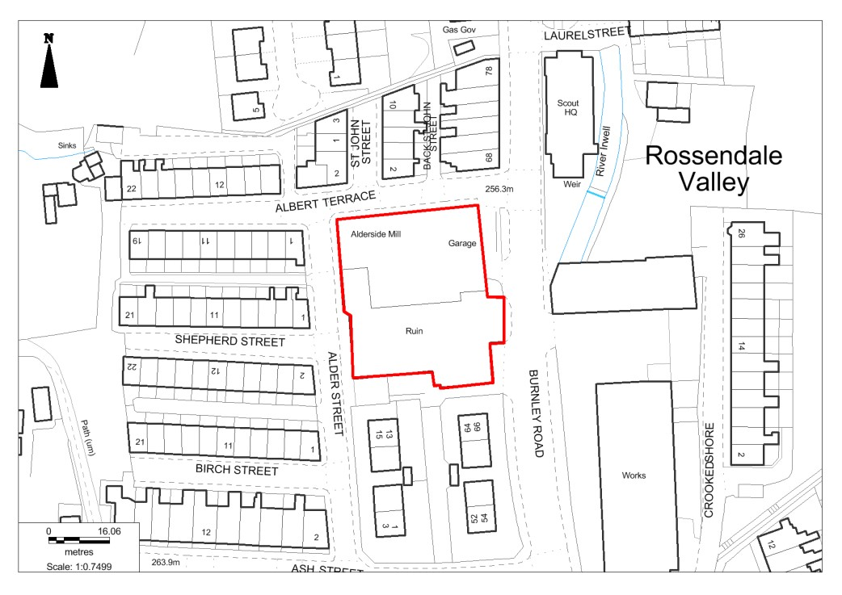  ((c) Crown copyright and database rights 2025 OS AC0000820722. You are permitted to use this data solely to enable you to respond to, or interact with, the organisation that provided you with the data. You are not permitted to copy, sub-licence, distribute or sell any of this data to third parties in any form.

Organisation URI | http://opendatacommunities.org/id/district-council/rossendale
Site Reference | ROSBS040
Site Name / Address | LAND TO SIDE AND REAR OF PETROL STATION, MANCHESTER ROAD
Site plan URL | https://www.rossendale.gov.uk/downloads/download/10897/brownfield_register
GeoY | 53.700799
GeoX | -2.318415
Hectares | 0.16
Ownership Status | Not owned by a public authority
Deliverable | No
Planning Status | Not permissioned
Permission Type
Permission Date
Planning History
Net Dwellings Range From | 6
Net Dwellings Range To
Hazardous Substances
Notes | Planning history: 2004/877. The Local Plan allocates the site (H46) for 6 dwellings.
First Added Date | 14/12/2018
Last Updated Date | 10/12/2025

Map | 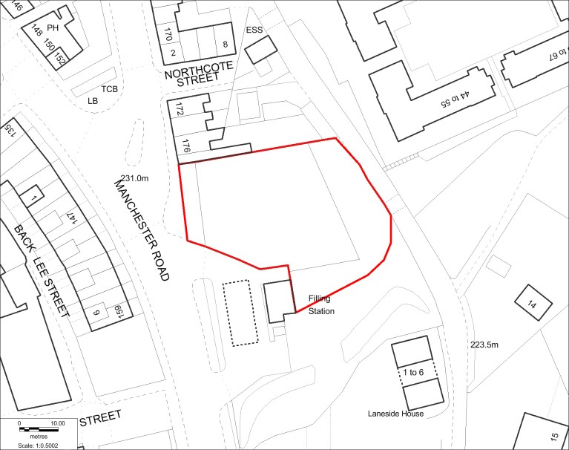  N  ▲  (c) Crown copyright and database rights 2025 OS AC0000820722. You are permitted to use this data solely to enable you to respond to, or interact with, the organisation that provided you with the data. You are not permitted to copy, sub-licence, distribute or sell any of this data to third parties in any form.

Organisation URI | http://opendatacommunities.org/id/district-council/rossendale
Site Reference | ROSBS044
Site Name / Address | BREARLEY ST GARAGE SITE
Site plan URL | https://www.rossendale.gov.uk/downloads/download/10897/brownfield_register
GeoY | 53.693547
GeoX | -2.216789
Hectares | 0.13
Ownership Status | Mixed ownership
Deliverable | No
Planning Status | Not permissioned
Permission Type
Permission Date
Planning History | The site is considered available, suitable and achievable but too small to be included in the housing land supply as it would deliver less than 5 dwellings.
Net Dwellings Range From | 3
Net Dwellings Range To
Hazardous Substances
Notes | DELETE?  The site is considered available, suitable and achievable but too small to be included in the housing land supply as it would deliver less than 5 dwellings.
First Added Date | 14/12/2018
Last Updated Date | 10/12/2025

Map | 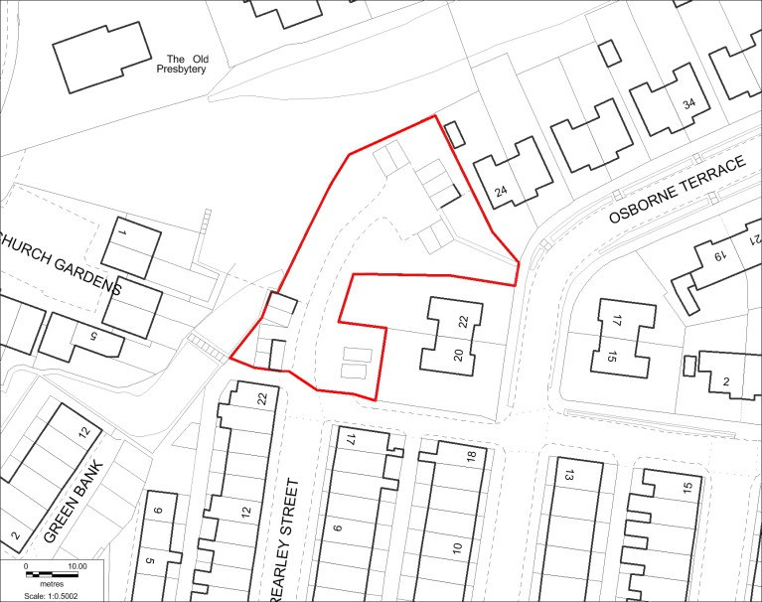  N  ▲  (c) Crown copyright and database rights 2025 OS AC0000820722. You are permitted to use this data solely to enable you to respond to, or interact with, the organisation that provided you with the data. You are not permitted to copy, sub-licence, distribute or sell any of this data to third parties in any form.

Organisation URI | http://opendatacommunities.org/id/district-council/rossendale
Site Reference | ROSBS045
Site Name / Address | VILLAGE PINE GLEN TOP WORKS, STACKSTEADS
Site plan URL | https://www.rossendale.gov.uk/downloads/download/10897/brownfield_register
GeoY | 53.6991179
GeoX | -2.241357
Hectares | 0.13
Ownership Status | Not owned by public authority
Deliverable | Yes
Planning Status | Permissioned
Permission Type | Full
Permission Date | 27/01/2025
Planning History | https://publicaccess.rossendale.gov.uk/online-applications/propertyDetails.do?activeTab=relatedCases&keyVal=MJLQIB00DT02Y
Net Dwellings Range From | 14
Net Dwellings Range To
Hazardous Substances
Notes | Planning application 2023/0553  Change of use and conversion of commercial unit to 14no apartments - previously approved application 2019/0101
First Added Date | 17/12/2020
Last Updated Date | 10/12/2025

Map | 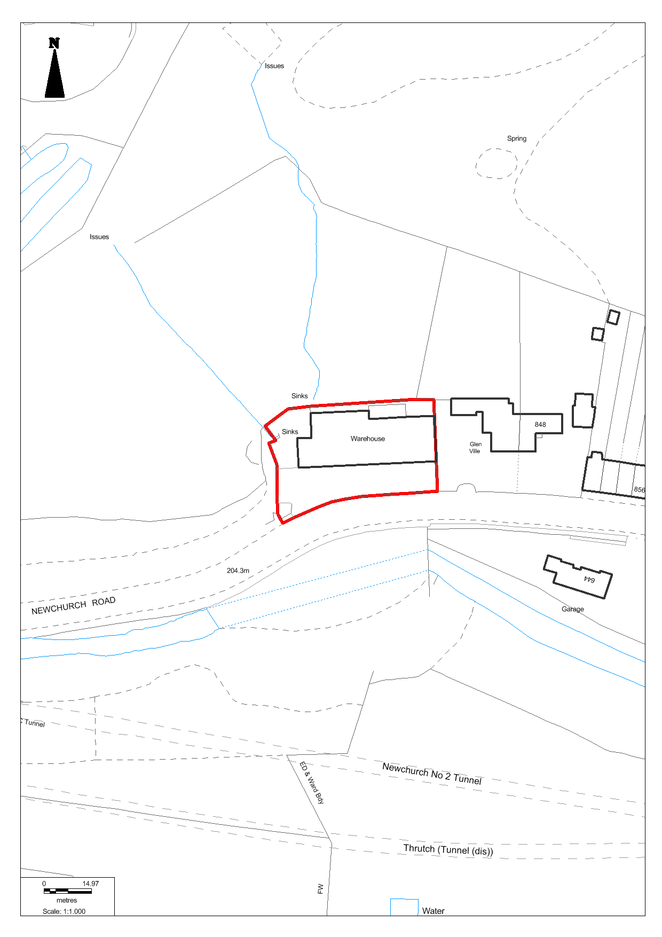  (c) Crown copyright and database rights 2025 OS AC0000820722. You are permitted to use this data solely to enable you to respond to, or interact with, the organisation that provided you with the data. You are not permitted to copy, sub-licence, distribute or sell any of this data to third parties in any form.

Organisation URI | http://opendatacommunities.org/id/district-council/rossendale
Site Reference | ROSBS047
Site Name / Address | THE HERITAGE ARCADE AND ADJACENT BUILDINGS AT 23-27 BACUP ROAD, RAWTENSTALL
Site plan URL | https://www.rossendale.gov.uk/downloads/download/10897/brownfield_register
GeoY | 53.70061
GeoX | -2.28585
Hectares | 0.09
Ownership Status | Not owned by public authority
Deliverable | Yes
Planning Status | Permissioned
Permission Type | Full Planning Permission
Permission Date | 21/01/2021
Planning History | https://publicaccess.rossendale.gov.uk/online-applications/propertyDetails.do?activeTab=relatedCases&keyVal=MJLQHQ00DT03T
Net Dwellings Range From | 42
Net Dwellings Range To
Hazardous Substances
Notes | Planning permission 2020/0018 granted.
First Added Date | 15/11/2021
Last Updated Date | 10/12/2025

Map | 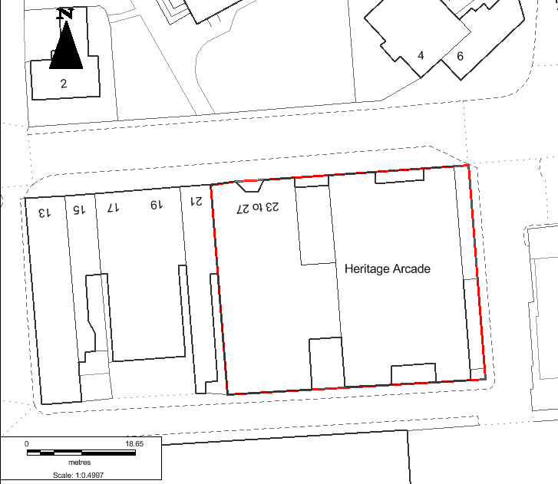  (c) Crown copyright and database rights 2025 OS AC0000820722. You are permitted to use this data solely to enable you to respond to, or interact with, the organisation that provided you with the data. You are not permitted to copy, sub-licence, distribute or sell any of this data to third parties in any form.

Organisation URI | http://opendatacommunities.org/id/district-council/rossendale
Site Reference | ROSBS048
Site Name / Address | LAND EAST OF MARKET STREET, EDENFIELD
Site plan URL | https://www.rossendale.gov.uk/downloads/download/10897/brownfield_register
GeoY | 53.67354
GeoX | -2.30503
Hectares | 0.31
Ownership Status | Not owned by public authority
Deliverable | No
Planning Status | Not permissioned
Permission Type
Permission Date
Planning History
Net Dwellings Range From | 9
Net Dwellings Range To
Hazardous Substances
Notes | The Local Plan allocates the site (H65) for 9 dwellings.
First Added Date | 15/11/2021
Last Updated Date | 10/12/2025

Map | 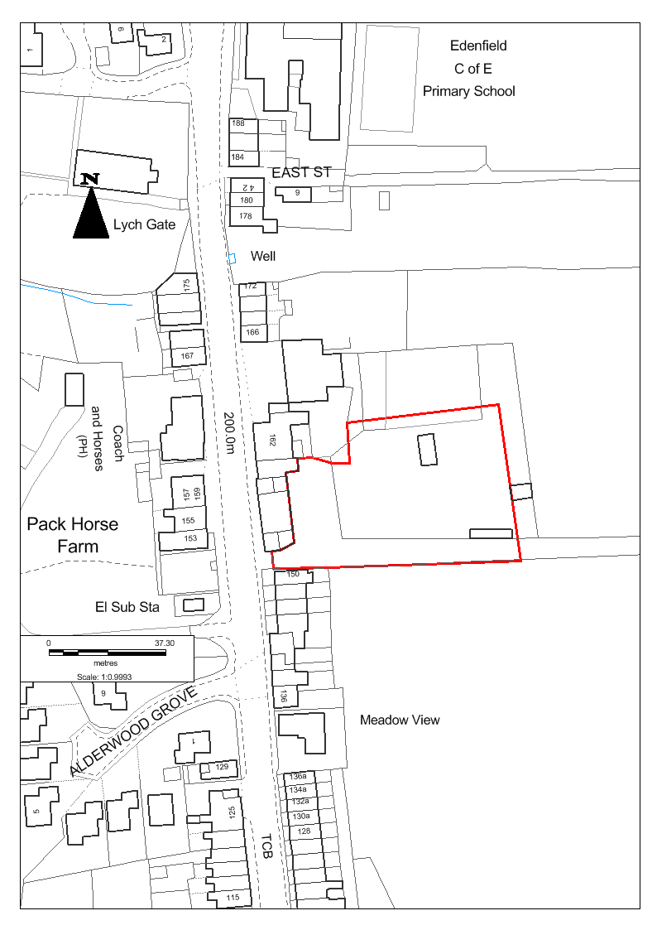  (c) Crown copyright and database rights 2025 OS AC0000820722. You are permitted to use this data solely to enable you to respond to, or interact with, the organisation that provided you with the data. You are not permitted to copy, sub-licence, distribute or sell any of this data to third parties in any form.

Organisation URI | http://opendatacommunities.org/id/district-council/rossendale
Site Reference | ROSBS019
Site Name / Address | FMR HASLINGDEN POLICE STATION
Site plan URL | https://www.rossendale.gov.uk/downloads/download/10897/brownfield_register
GeoY | 53.0724
GeoX | -2.32278
Hectares | 0.13
Ownership Status | Not owned by public authority
Deliverable | Yes
Planning Status | Permissioned
Permission Type | Full Planning Permission
Permission Date | 10/03/2016
Planning History | https://publicaccess.rossendale.gov.uk/online-applications/propertyDetails.do?activeTab=relatedCases&keyVal=MJLQFS00DT02X
Net Dwellings Range From | 8
Net Dwellings Range To
Hazardous Substances
Notes | Planning Approval 2016/0320. Police station has been demolished. Local Plan allocates the site (H40) for 8 dwellings. Seemingly no works in recent years - hence re-inclusion of the site on the register.
First Added Date | 15/12/2017
Last Updated Date | 10/12/2025

Map | 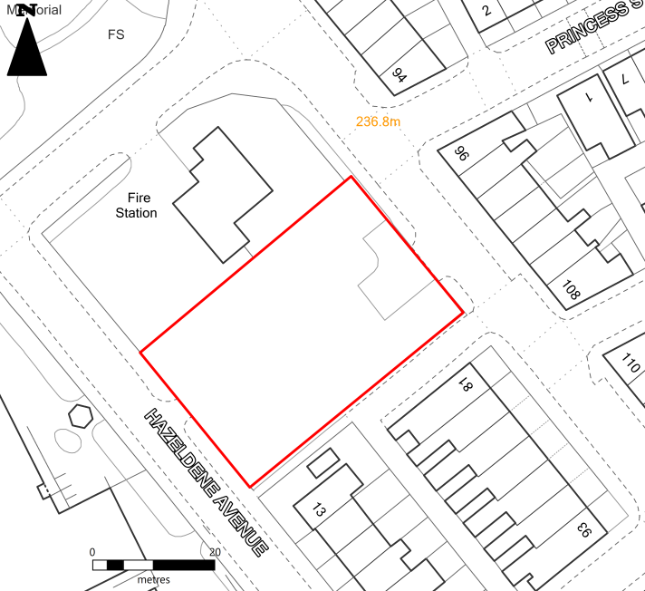  (c) Crown copyright and database rights 2025 OS AC0000820722. You are permitted to use this data solely to enable you to respond to, or interact with, the organisation that provided you with the data. You are not permitted to copy, sub-licence, distribute or sell any of this data to third parties in any form.

Organisation URI | http://opendatacommunities.org/id/district-council/rossendale
Site Reference | ROSBS050
Site Name / Address | FORMER CAR PARK, PARK ROAD, HELMSHORE
Site plan URL | https://www.rossendale.gov.uk/downloads/download/10897/brownfield_register
GeoY | 53.7268
GeoX | 2.1901
Hectares | 0.27
Ownership Status | Not owned by public authority
Deliverable | No
Planning Status | Permissioned
Permission Type | Full Planning Permission
Permission Date | 15/06/2021
Planning History | https://publicaccess.rossendale.gov.uk/online-applications/applicationDetails.do?activeTab=relatedCases&keyVal=Q87K5MND04J00
Net Dwellings Range From | 8
Net Dwellings Range To
Hazardous Substances
Notes | 2020/0160 - no start appeared to have been made on the site as of 31/03/2022.  Construction of 8 no. three-bedroom dwellings, with associated access and works.
First Added Date | 15/11/2022
Last Updated Date | 10/12/2025

Map | 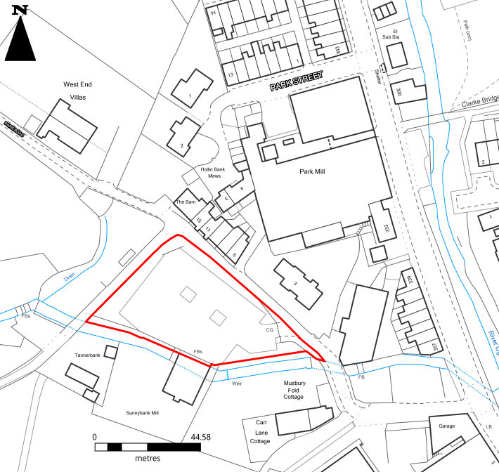  (c) Crown copyright and database rights 2025 OS AC0000820722. You are permitted to use this data solely to enable you to respond to, or interact with, the organisation that provided you with the data. You are not permitted to copy, sub-licence, distribute or sell any of this data to third parties in any form.

Organisation URI | http://opendatacommunities.org/id/district-council/rossendale
Site Reference | ROSBS051
Site Name / Address | 2 WARNER ST, HASLINGSDEN
Site plan URL | https://www.rossendale.gov.uk/downloads/download/10897/brownfield_register
GeoY | 53.7033
GeoX | -2.3251
Hectares | 0.13
Ownership Status | Not owned by a public authority
Deliverable | Yes
Planning Status | Not permissioned
Permission Type | Outline
Permission Date | 17/06/2022
Planning History | https://publicaccess.rossendale.gov.uk/online-applications/propertyDetails.do?activeTab=relatedCases&keyVal=MJLQCD00DT023
Net Dwellings Range From | 5
Net Dwellings Range To
Hazardous Substances
Notes | 2020/0124 - Erection of 5no 1bed bungalows, including parking for 3no cars by Cordingly's Garage. Planning permission expired.
First Added Date | 17/11/2023
Last Updated Date | 10/12/2025

Map | 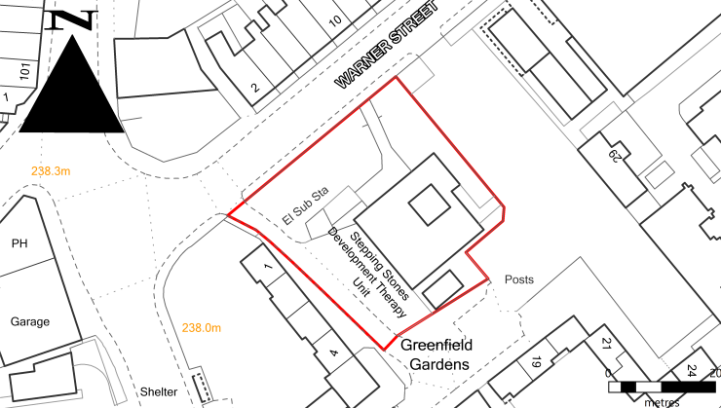  (c) Crown copyright and database rights 2025 OS AC0000820722. You are permitted to use this data solely to enable you to respond to, or interact with, the organisation that provided you with the data. You are not permitted to copy, sub-licence, distribute or sell any of this data to third parties in any form.

Organisation URI | http://opendatacommunities.org/id/district-council/rossendale
Site Reference | ROSBS053
Site Name / Address | CROWN INN, GREAVE RD, BACUP
Site plan URL | https://www.rossendale.gov.uk/downloads/download/10897/brownfield_register
GeoY | 53.70728
GeoX | -2.18918
Hectares | 0.07
Ownership Status | Not owned by a public authority
Deliverable | No
Planning Status | Not Permissioned
Permission Type | Full
Permission Date | 04/09/2020
Planning History | https://publicaccess.rossendale.gov.uk/online-applications/propertyDetails.do?activeTab=relatedCases&keyVal=MJLQDM00DT005
Net Dwellings Range From | 5
Net Dwellings Range To
Hazardous Substances
Notes | Full: single storey lean-to extension at ground floor level to form beer cellar  and upper floor alterations to form 5 No. residential flats including second  floor extension, with associated works. Permission expired.
First Added Date | 22/11/2023
Last Updated Date | 11/12/2025

Map | 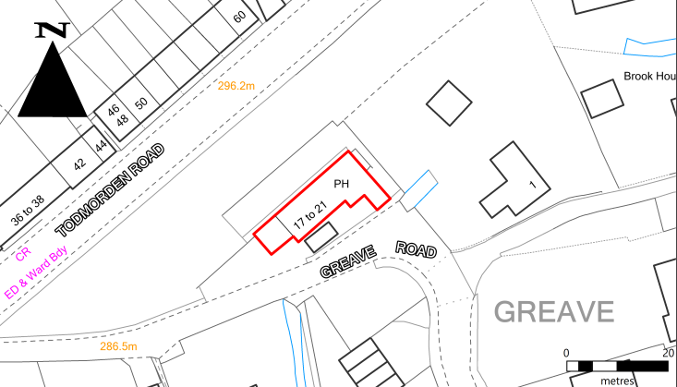  (c) Crown copyright and database rights 2025 OS AC0000820722. You are permitted to use this data solely to enable you to respond to, or interact with, the organisation that provided you with the data. You are not permitted to copy, sub-licence, distribute or sell any of this data to third parties in any form.

Organisation URI | http://opendatacommunities.org/id/district-council/rossendale
Site Reference | ROSBS054
Site Name / Address | IRWELL VALE MILL
Site plan URL | https://www.rossendale.gov.uk/downloads/download/10897/brownfield_register
GeoY | 53.67911
GeoX | -2.31777
Hectares | 0.69
Ownership Status | Not owned by public authority
Deliverable | Yes
Planning Status | Permissioned
Permission Type | Outline
Permission Date | 07/09/2021
Planning History | https://publicaccess.rossendale.gov.uk/online-applications/propertyDetails.do?activeTab=relatedCases&keyVal=MJLQGJ00DT024
Net Dwellings Range From | 30
Net Dwellings Range To
Hazardous Substances
Notes | The Local Plan allocates the site (H64) for 30 dwellings.  Application 2024/0342 Reserved Matters Pursuant to Outline Planning Permission 2019/0405 Pending Consideration.
First Added Date | 22/11/2023
Last Updated Date | 11/12/2025

Map | 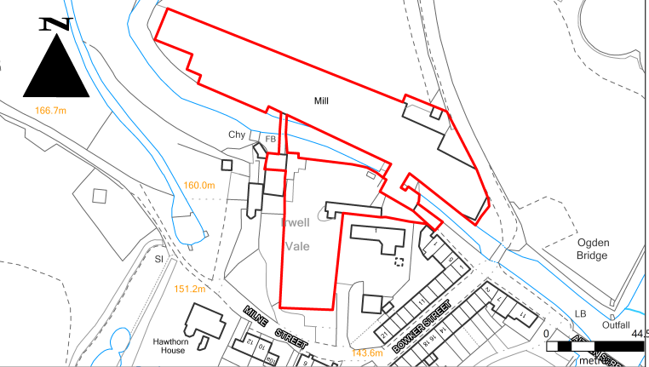  (c) Crown copyright and database rights 2025 OS AC0000820722. You are permitted to use this data solely to enable you to respond to, or interact with, the organisation that provided you with the data. You are not permitted to copy, sub-licence, distribute or sell any of this data to third parties in any form.

Organisation URI | http://opendatacommunities.org/id/district-council/rossendale
Site Reference | ROSBS028
Site Name / Address | GLEN MILL, STACKSTEADS
Site plan URL | https://www.rossendale.gov.uk/downloads/download/10897/brownfield_register
GeoY | 53.6909
GeoX | -2.2407
Hectares | 0.18
Ownership Status | Not owned by public authority
Deliverable
Planning Status | Not permissioned
Permission Type
Permission Date
Planning History | https://publicaccess.rossendale.gov.uk/online-applications/applicationDetails.do?activeTab=summary&keyVal=OMX8STNDGNP00
Net Dwellings Range From | 9
Net Dwellings Range To
Hazardous Substances
Notes | The Local Plan allocates the site (H20) for 9 dwellings.
First Added Date | 15/12/2017
Last Updated Date | 27/11/2024

Map | 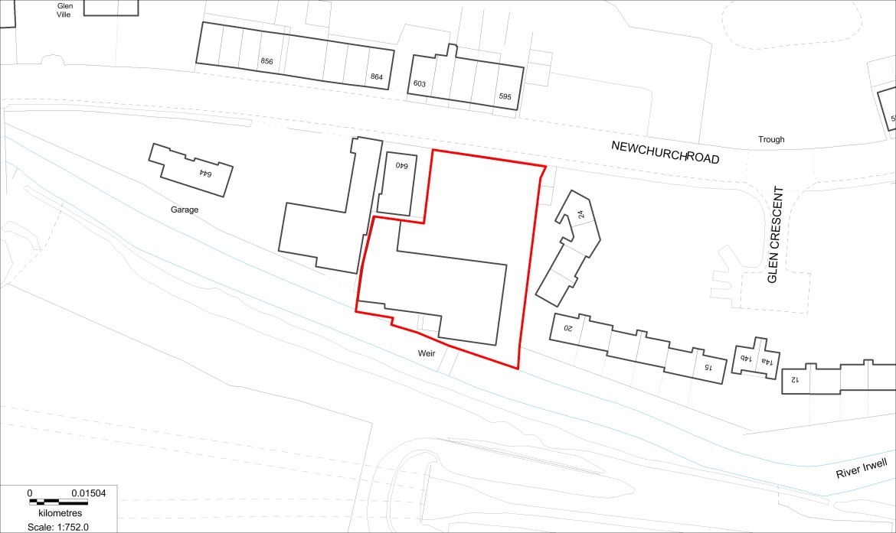  N  ▲  (c) Crown copyright and database rights 2025 OS AC0000820722. You are permitted to use this data solely to enable you to respond to, or interact with, the organisation that provided you with the data. You are not permitted to copy, sub-licence, distribute or sell any of this data to third parties in any form.

Organisation URI | http://opendatacommunities.org/id/district-council/rossendale
Site Reference | ROSBS011
Site Name / Address | FMR COMMERCIAL HOTEL, STACKSTEADS
Site plan URL | https://www.rossendale.gov.uk/downloads/download/10897/brownfield_register
GeoY | 53.6914
GeoX | -2.22431
Hectares | 0.04
Ownership Status | Not owned by public authority
Deliverable | Yes
Planning Status | Part permissioned
Permission Type | Full
Permission Date | 15/11/2024
Planning History | https://publicaccess.rossendale.gov.uk/online-applications/applicationDetails.do?activeTab=relatedCases&keyVal=SH6SEQNDHRK00
Net Dwellings Range From | 7
Net Dwellings Range To
Hazardous Substances
Notes | Planning permission 2024/0315 for the conversion of the former Commercial Hotel to a 13-bed HMO has been approved. The Local Plan allocates the site (H21), including 318A, 316B & 318C, for 7 dwellings - but it is appearing that the remainder of the site may not be coming forward for development.
First Added Date | 15/12/2017
Last Updated Date | 11/12/2025

Map | 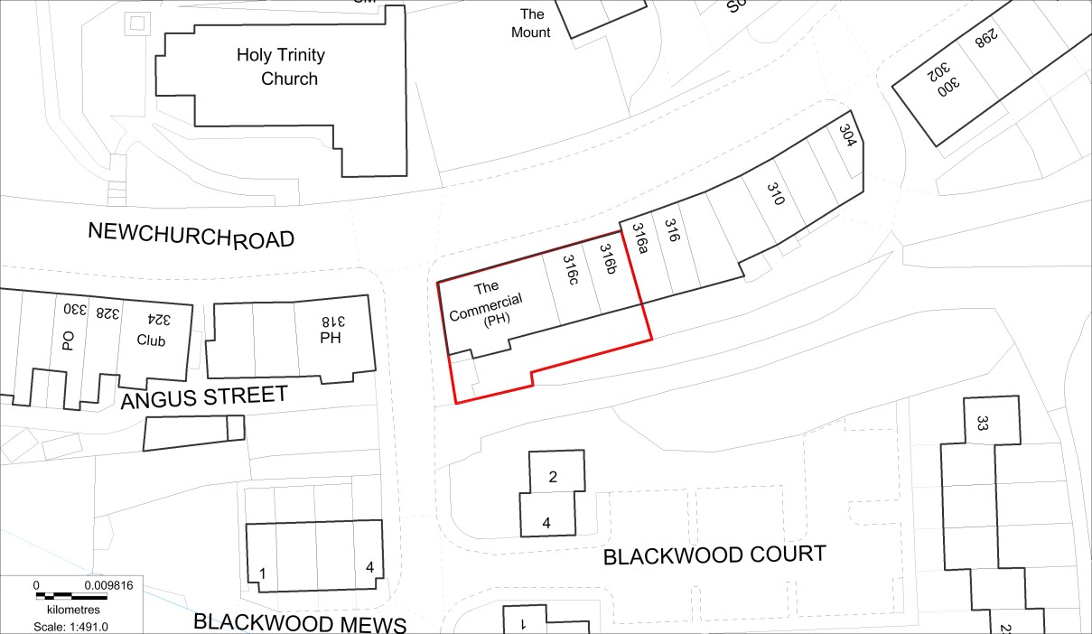  N  ▲  (c) Crown copyright and database rights 2025 OS AC0000820722. You are permitted to use this data solely to enable you to respond to, or interact with, the organisation that provided you with the data. You are not permitted to copy, sub-licence, distribute or sell any of this data to third parties in any form.

Organisation URI | http://opendatacommunities.org/id/district-council/rossendale
Site Reference | ROSBS055
Site Name / Address | ADJACENT 93 BURNLEY ROAD BACUP LANCASHIRE OL13 8PZ
Site plan URL | https://www.rossendale.gov.uk/downloads/download/10897/brownfield_register
GeoY | 53.722
GeoX | -2.19737
Hectares | 0.2
Ownership Status | Not owned by a public authority
Deliverable | Yes
Planning Status | Permissioned
Permission Type | PIP (Permission in Principle)
Permission Date | 25/10/2024
Planning History | https://publicaccess.rossendale.gov.uk/online-  applications/propertyDetails.do?activeTab=relatedCases&keyVal=MJLQHI00DT00L
Net Dwellings Range From | 1
Net Dwellings Range To | 8
Hazardous Substances
Notes | Planning application 2024/0154 refused 07/06/2024. Appeal allowed 25/10/2024.
First Added Date | 12/15/2017
Last Updated Date | 11/12/2025
Map | 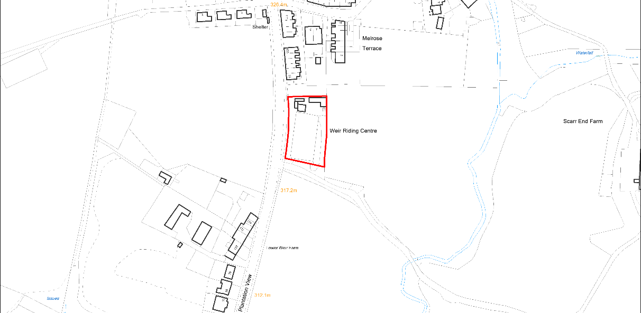  N  ▲  (c) Crown copyright and database rights 2025 OS AC0000820722. You are permitted to use this data solely to enable you to respond to, or interact with, the organisation that provided you with the data. You are not permitted to copy, sub-licence, distribute or sell any of this data to third parties in any form.

Organisation URI | http://opendatacommunities.org/id/district-council/rossendale
Site Reference | ROSBS056
Site Name / Address | THE OFFICES PEEL MILL MARKET STREET SHAWFORTH ROCHDALE LANCASHIRE OL12 8HN
Site plan URL | https://www.rossendale.gov.uk/downloads/download/10897/brownfield_register
GeoY | 53.6849
GeoX | -2.16613
Hectares | 0.10
Ownership Status | Not owned by public authority
Deliverable | Yes
Planning Status | Permissioned
Permission Type | Prior approval
Permission Date | 19/07/2024
Planning History | https://publicaccess.rossendale.gov.uk/online-applications/applicationDetails.do?activeTab=documents&keyVal=SCC14NNDI8F00
Net Dwellings Range From | 7
Net Dwellings Range To
Hazardous Substances
Notes | Prior approval application 2024/0162 for a proposed change of use from Commercial, business and service (use class E) to Dwellinghouse (use class C3)
First Added Date | 15/12/2017
Last Updated Date | 11/12/2025
Map | 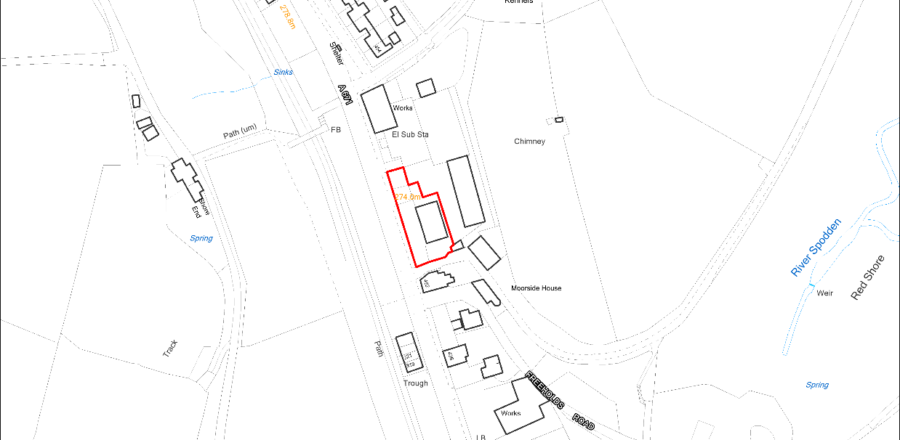  N  ▲  (c) Crown copyright and database rights 2025 OS AC0000820722. You are permitted to use this data solely to enable you to respond to, or interact with, the organisation that provided you with the data. You are not permitted to copy, sub-licence, distribute or sell any of this data to third parties in any form.



